Sienna Niggea
ID: 00253

Task 4 – Design and Modelling deliverrable
CMN224 Software Engineering

Introduction
This task assembles both the design and modelling work done across the weeks in each lab. It shows the structural views such as the package and deployment diagrams done in week 5. Each of these diagrams illustrate ho the whagi valley depot system will work, ensuring that there is consistency with the requirements collected and explanations for each of the diagrams. Together, all these diagrams demonstrate how the system will support both normal day-to-day operations and a centralized oversight at the town office.
- Outline Architecture
Figure 1.1: Package Diagram
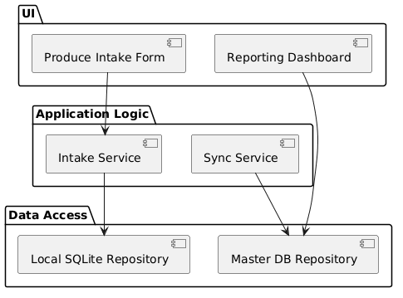
This diagram divides the system into the following; The User Interface (UI), Application Logic, and Data Access. The separation of each layer ensures that the depot staff are only able to interact with the Intake Form, while the synchronization and reporting once back online are then handled by the services. This helps with supports maintainability whilst preventing any upwards dependency arrows.
- Figure 2: Deployment Diagram
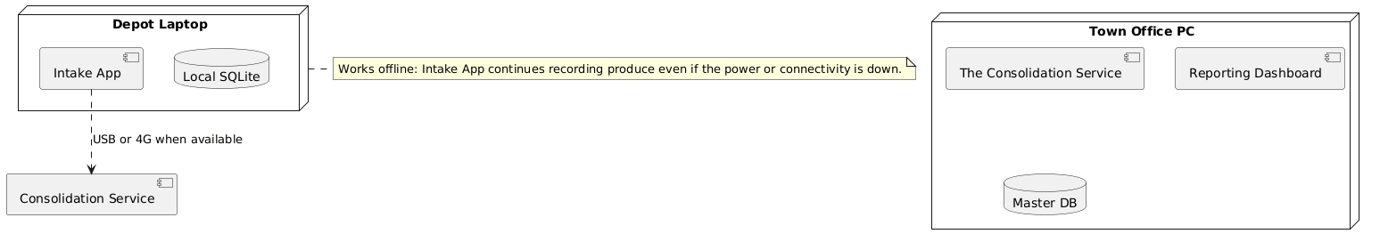
The diagram above illustrates the deployment aspect where the Depot Laptop hosts the Intake App and the Local SQLite, where from the Depot laptop they are still able to work offline even with the power and connectivity issues. In the Town office PC, it hosts the Consolidation Service, a Reporting Dashboard, and the Master DB. Additionally, the Connectivity can be connected via USB or 4G when available. The decision of an offline-first design helps ensures that the depot laptops can continue recording the produces during connectivity and power outages. This is where synchronization occurs once the connectivity is restored while also making sure and flagging duplicate entries during consolidation.
- Figure 3: Use Case Diagram
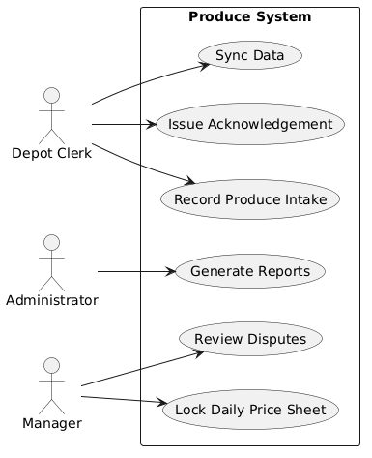
The use case diagram shows and captures the external perspective of the system, where it shows the Depot Clerk, Administrator, and the Manager and how they interact with the systems functions like the recording produce, issuing od acknowledgements, Sync Data, generating reports, and locking the daily price sheets. Each of these use cases traces directly to the Functional Requirements established, this ensures that the model is fit and grounded for the stakeholder’s needs. The depot clerk is responsible for recording produce intake (FR-1 record produce intake including the member number, crop, grade, kilograms, date, and the price), and also issuing acknowledgements (inline with FR-4, where it generates a printable acknowledgement for each delivery), and then syncing data when the connectivity is available. The Administrator uses the system to generate the consolidated reports which ensures transparency in the report. This goes in line with FR-5 which allows the manager to lock the daily price sheets and review the records. Lastly, The Manager is able to interact with the features that enforce the business rules, like locking the daily price sheets (FR-5) and reviewing the disputes and helps ensures that there is compliance with the cooperative policies. These use cases directly trace to the elicitation requirements done for this task, ensuring that every actor’s goals are represented correctly and that the system supports both the operational tasks at the depot and oversight functions at the town office.
- Figure 4: Class Diagram
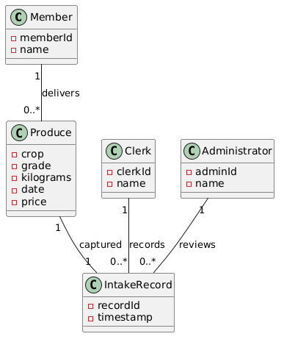
In this diagram, it captures the logical structure of the system, which includes the entities such as Member, Produce, IntakeRecord, Clerk, and Administrator. These entities have attributes and multiplicities of theirs below them in the diagram and each of them can relate to other attributes in another entity. Each of the use cases from figure 3 interact with these classes. For example, the attribute clerkId, one Clerk can record many IntakeRecords (recordId) which is another attribute that belong to the Clerk entity. The decision for this design was that adding attributes like recordId and timestamp makes each record unique and traceable. This will help detect duplicates made during the consolidation and ensures data integrity in the system. The one-to-many relationships encode real business rules such as, one clerk handles many records, or one admin reviews many records.
- Figure 5: State Diagram
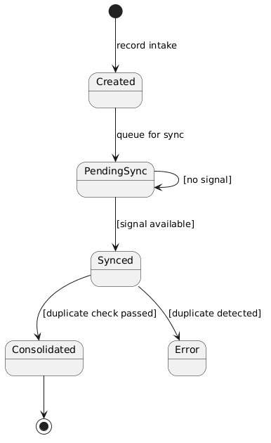
The state diagram shows how a Produce Record changes over time. When a clerk records the produce, as shown above, the record starts in the Created state. If there is no signal, it will stay in the Pending Sync. However, if there is signal, once connectivity is restored and synced. The record then moves to Synced. Before it reaches consolidation, the system will check for duplicates and if there are no duplicates it passes the check and becomes consolidated. If it does not pass, it instead goes to error. For example, One Administrator can review many IntakeRecords. Each of the recordId then moves through these states, and the admin makes sure that the consolidated records are correct.
- Workflow Across Devices
Figure 6: Activity Diagram
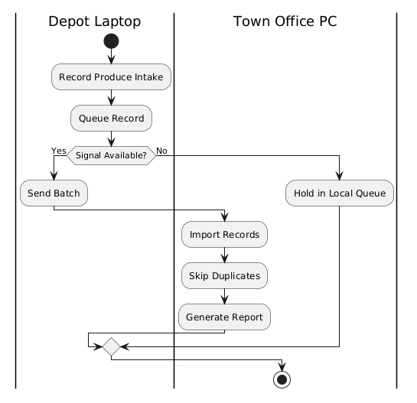
The Activity diagram captures and shows the workflow across devices. Firstly, on the Depot Laptop, the clerk records the produce and queues it. If the signal is available, the batch is then sent to the Town office PC on the right, where the records are then imported, the duplicates are skipped, and the reports are generated. If there is no signal, the records stay in the local queue until the connectivity returns. On the Depot Laptop, the clerk begins at the start node by recording the producer intake and queuing the record. In the decision node, it then checks whether the signal is available. If the condition is True, the workflow then follows the yes branch sending the batch to the Town Office PC, where it imports the records, then skips the duplicates, and lastly generates a report. However, if the condition is false, it follows the no branch and holds the records in the local queue until connectivity is restored.

Conclusion
This task brought together all the main parts of the package diagram. Firstly, we started with the package diagram which showed the layered architecture. Then the deployment diagram which showed where the system run. We also added the case diagram to explain how the actors interact with the system, and the class diagram showed the main entities and attributes and how they relate with each other and their relationships. We also added the state diagram which described how a produce record changes over time, and the activity diagram showed the workflow across the devices and what happens when the network is down. Altogether, these diagrams give a clear picture of how the system works, and how it meets the requirements of the stakeholders, and how it supports both the depot staff and the administrators.

AI Usage:
I used copilot as my Ai assistance to help me draft up the PlantUML text code for my UML diagrams. I also used it to help refine my wording and the explanations to make them clearer and more accurate. I also used it to check against the requirements of this task to check if I met the requirements of this task.

